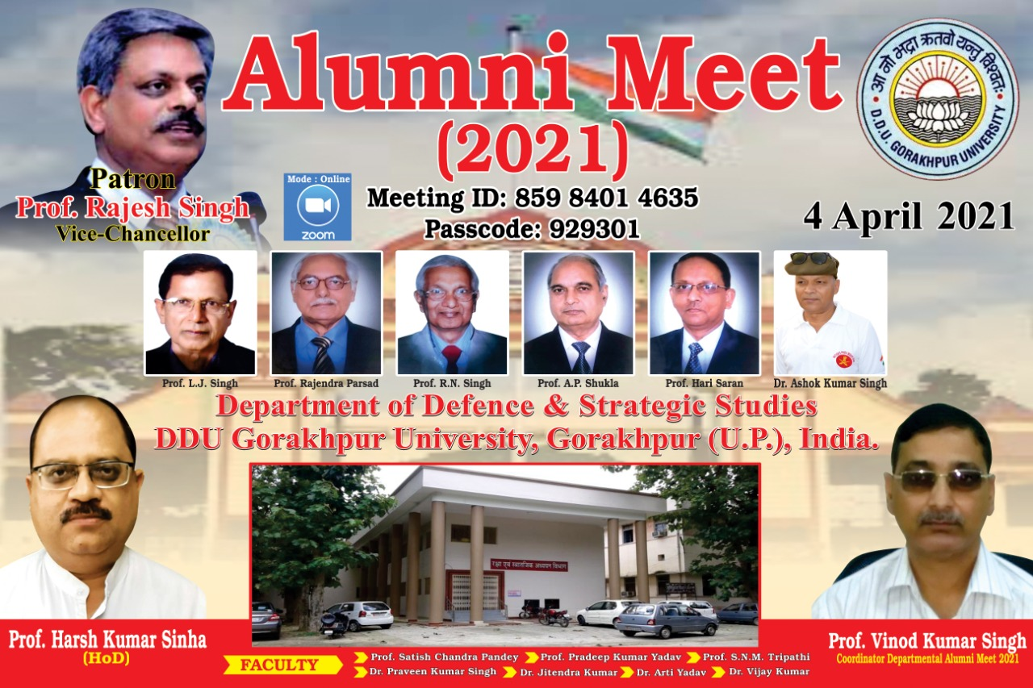

D.D.U. Gorakhpur University, Gorakhpur
Department of Defence & Strategic Studies

S.No. | Name | Year | Present Working Address | Mobile no.
1 | Dr. Praveen Kumar Singh | 1998-2000, 2003-2007 | Department of Defence & Strategic Studies D.D.U. Gorakhpur University, Gorakhpur | 9415280253
2 | Dr. Jitendra Kumar | 1998-2007 | Department of Defence & Strategic Studies D.D.U. Gorakhpur University, Gorakhpur | 8182834300
3 | Dr. Arti Yadav | 2004-05,2008-15 | Department of Defence & Strategic Studies D.D.U. Gorakhpur University, Gorakhpur | 9450623909
4 | Dr. Vijay Kumar | 2011-2017 | Department of Defence & Strategic Studies D.D.U. Gorakhpur University, Gorakhpur | 9696213022
5 | Dr.Baburam Dushad | 2014 | Sub-Inspector UPP | 9559144712
6 | Sri Prem Kumar Patwa | 2014 | Assistant Prof., A.N.D. Kisan P.G.College, Babhanan, Gonda | 8318839348
7 | Sri Devendra Pandey | 2014 | Assistant Prof., A.N.D. Kisan P.G.College, Babhanan, Gonda | 97956042333
8 | Sri Amit Tripathi | 2014 | Assistant Prof., A.N.D. Kisan P.G.College, Babhanan, Gonda | 8687945194
9 | Sri Jitendra Kumar Verma | 2013-2018 | Assist. Prof. M .M.M .Town P.G. College, Ballia | 8004582562
10 | Dr. Jitendra Yadav | 2013-2018 | Guest Faculty, Allahabad Central University, Prayagra | 8931909481
11 | Dr. Satish Kumar Rai | 2019 | Assist. Prof. Swami Sahjanand P.G. College, Ghazipur | 9415269522
12 | Dr. Vibha Rai |  | Assist. Prof. Swami Sahjanand P.G. College, Ghazipur | 9415288082
13 | Dr.Anup Kumar Srivastava | 2011 | Assist. Prof. , Bhatwali Mahavidyalaya Bhatwali, Gorakhpur | 9451441475
14 | Nitish Srivastava |  | Sr.Assist./Reader, District Court Gorakhpur | 7800332500
15 | Anand Kumar Shahi |  | Labour Welfare Officer, JSW Ispat Limited, Raipur | 7987941265
16 | Ajay Pal | 2000 | Jourlist | 9415180338
17 | Dr. Siddharth Nath Shukla | 2019 | Assist.Prof. J.L.N. P.G.College, Mahrajganj | 835497687
18 | Dr. Ajay Mishra | 2019 | Assist. Prof., Saket P.G. College.Ayodhyaya | 9795123100
19 | Dr.Dinesh Chandra Tripathi | 2013 | Principal, Chhotelal Damodar Prasad Shibban lal P.G.College, Maharajganj | 9956117525
20 | Dr. Shailendra Kumar | 2015 | Sale Tax Officer (PCS) Agra | 9415346665
21 | Dr. M.M.Shukla | 2008&2019 | Assist. Prof. Hindu College Moradabad | 9454001140
22 | Dr.Sunil Kumar | 2017 | Assist. Teacher, Basic Shiksha Prayagraj | 8808613763
23 | Pusphas Tripathi | 2016 | Sales Officer, HDFC, Bank Khajni Gorakhpur | 8853618218
24 | Dr. Abhishikh Singh | 2011 | Assist. Prof. M.P.P. G.College Jangle Dhushan, Gorakhpur | 9935770187
25 | Dr. Rama Kant Dubey | 2019 | Assist. Prof. M.P.P. G.College Jangle Dhushan, Gorakhpur
26 | Dr.Anshuman Singh | 2014&2019 | Assist. Prof., M. M. M. P.G.College, Bhatparrani, Deoria
27 | Km. Sonam Singh | 2016 | Assist. Teacher, Basic Shiksha | 8574318228
28 | Sri Ashawani Verma | 2019 | Disaster Management Office Gorakhpur
29 | Dr. Ram Kumar Yadav | 2011-2017 | Lecturer, S.S.K. Inter College, Hapur | 9956278806
30 | Sri Sanjeev Singh | 2018 | Disaster Expert, D.D.M A,. Varanasi | 8957662020

