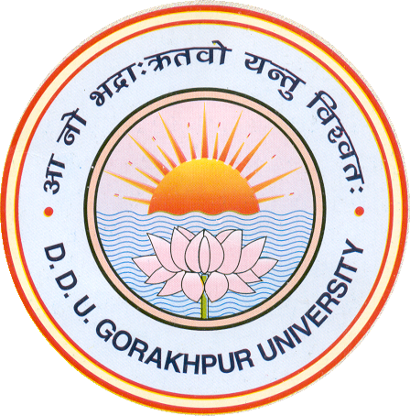DEPARTMENT OF BOTANY

DDU GORAKHPUR UNIVERSITY, GORAKHPUR, UP

List of awards/ recognition achieved by faulty members in last 5 years

- Por V N Pandey- Life time achievement award by Asian Biological research foundation, Prayagraj, Sept, 2019.
- Prof V N Pandey- Awarded corresponding membership of Botanical Society of America (BSA), 2018.
- Dr K Sunita- awarded women scientist in Conference held at CAS in Botany, Institute of Sciences, BHU, Varanasi in 2020.
- Dr Smriti mall- awarded Certificate of Appreciation from Rotary club, Gorakhpur
- Dr K Sunita- Awarded best oral presentation in IPS conference IARI in January, 2020.
- Dr Shweta Shekhar awarded best oral presentation in international Symposium on current scenario and social environmental challenges. By BSI, Prayagraj.
- Prof Pooja Singh –invited to contribute a chapter in prestigious UNESCO publication encylopedia of life support systems. EOLSS.

Prof Pooja Singh
Head, Department of Botany
DDU Gorakhpur University

